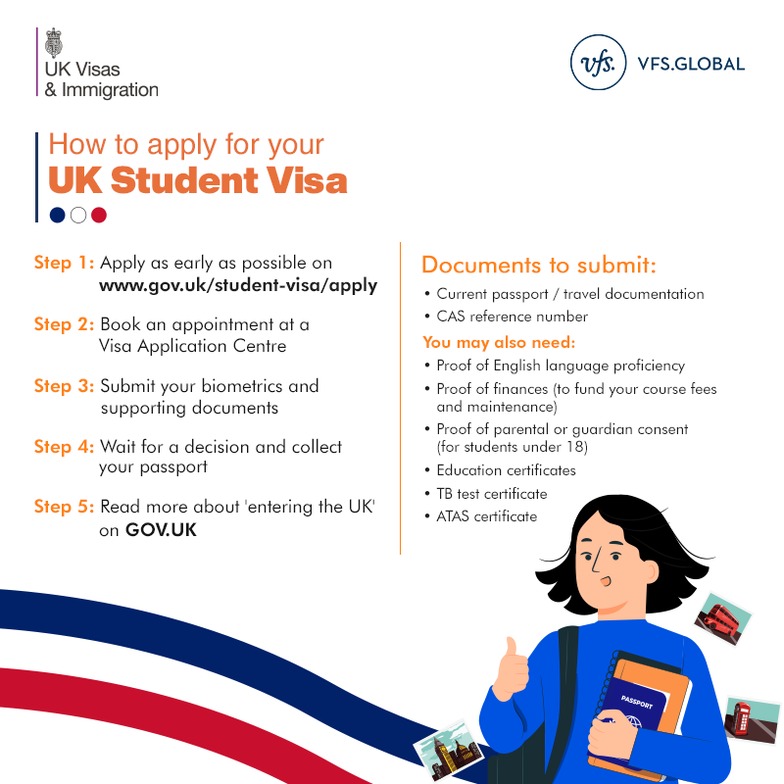

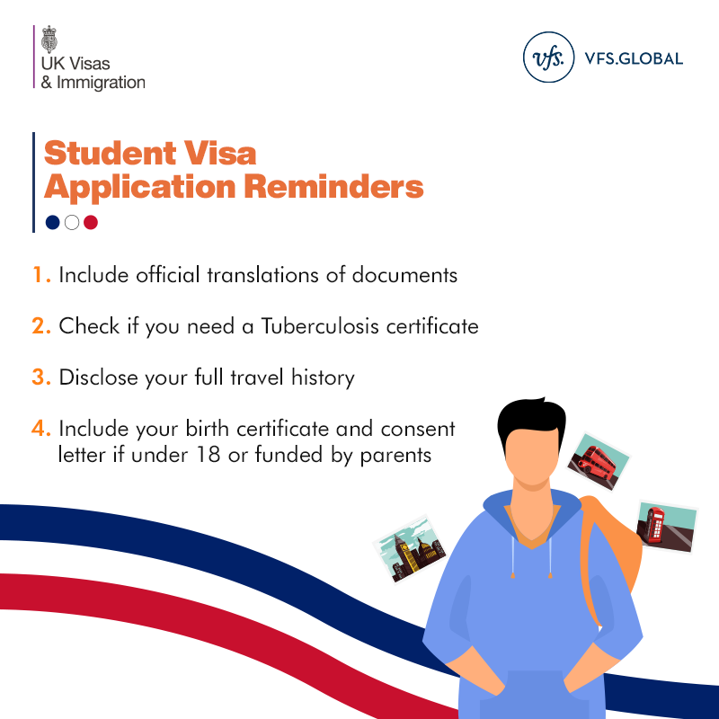

**We have some updates from you posted recently regarding applying for a Student Visa. It not as complicated as it seem! Watch the video below to see more detailed information that you see on the infographic.**



**Here are the terms that might sound foreign, explained so you won’t feel intimidated:**

## [CAS](https://www.gov.uk/student-visa/course) -Confirmation of Acceptance for Studies, number that you receive once you get unconditional offer from the educational provider.

# [ATAS](https://www.gov.uk/guidance/academic-technology-approval-scheme)-Academic Technology Approval Scheme, certificate that you have to obtain in order to study certain subjects.

# TB-Tuberculosis tests, not required for Poland, but required if you lived in [those listed countries](https://www.gov.uk/tb-test-visa/countries-where-you-need-a-tb-test-to-enter-the-uk) in the last 6 months.

**Also a couple of reminders regarding the overall application process:**

* **Schedule is usually different for postgrad students than undergrad.**
* **Remember that some language test have expiration date**. And even if they are for life (CAE, CPE), university might ask you for the one that was done no more than 2 years prior.
* **Check the requirement for the language test grade. Some universities have a specific ask for the**
* **Some universities require a transfer of grades.** They have to be done in English, so plan ahead to be prepared.
* **Remember to take the cost of the visa application into consideration**. It costs £363 to apply from outside the UK.
* **Different programmes have different deadlines, even at the same university (especially the medical field).** Some course providers require additional admissions tests to be taken alongside the UCAS application, and these may have a deadline. [Find out more about these tests](https://www.ucas.com/undergraduate/applying-university/admissions-tests). **Check course information in our**[search tool](https://digital.ucas.com/search)**to see which deadline applies to you.**
* **The application schedule differs between universities. The majority have deadlines by the end of January or early Spring, so be very careful to check.**

**Remember to apply as soon as possible**! Both for the Visa and your chosen courses. 